Abhik Mondal  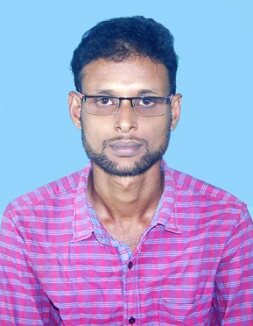  E- mail  sentmailtoabhik@gmail.com  Contact Number  Mob: +91-9804123577  Permanent Address  Vill.-Shitalpur,P.O.+P.S.-Shyampur,Dist.-Howrah,Pin.-711314  Father's Name  Jaladhar Mondal  Date of Birth  24-04-1995  Sex  Male  Nationality  Indian  Marital Status  Single  Hobbies:  Listening Music,  Photography,  Travelling | Aim / Career Objective  To obtain a responsible position where I can apply my knowledge and skills with an opportunity for professional challenge and enhance the objectives of the esteemed organization  Education  Stream : Chemical Technology (Specialization in Petrochemicals & Petroleum Refinery Engineering)  Computer / IT Skills  Achievements  - Played a Cricket tournament for our college(PPR).  - Got merit cum means scholarship for Secondary Examination from Govt.of India, Ministry of Human Resource Development, Department of Higher Education in 2010.  Languages  - English (Read,Write & Speak)  - Bengali (Read,Write & Speak)  - Hindi (Speak)  Training Project  Indian Oil Corporation Limited, Haldia  Duration: 21.05.2018-20.06.2018  Project Details: Basics of refinery downstream processes.
  Examination/ Degree | Institution | Performance |  | Year of completion
  B.Tech(University Of Calcutta) | University College of Science and Technology | 3rd Sem | 8.08 | 2019
  B.Tech(University Of Calcutta) | University College of Science and Technology | 4th Sem | 8.50 | 2019
  B.Tech(University Of Calcutta) | University College of Science and Technology | 5th Sem | 8.25 | 2019
  B.Tech(University Of Calcutta) | University College of Science and Technology | 6th Sem | 7.42 | 2019
  B.Tech(University Of Calcutta) | University College of Science and Technology | 7th Sem | 9.18 | 2019
  B.Tech(University Of Calcutta) | University College of Science and Technology | 8th Sem | 8.13 | 2019
  B.Tech(University Of Calcutta) | University College of Science and Technology | CGPA | 8.25
  B.Sc(Hons in Chemistry) | Vidyasagar College(University Of Calcutta) | Aggregrate=63.875% |  | 2016
  Higher Secondary Education (12th) (WBCHSE) | Shyampur High School | Aggregate = 85.6% |  | 2012
  Secondary Education (10th) (WBBSE) | Shyampur High school | Aggregate =81% |  | 2010
  Software | Microsoft Office (Word, Power point, Excel)

Declaration
I hereby declare that the information given above is true to the best of my knowledge and belief and can be supported with reliable documents when needed.

________________________

Abhik Mondal

Date: 08-08-2019
Place: Kolkata

