 CURRICULUM-VITAE

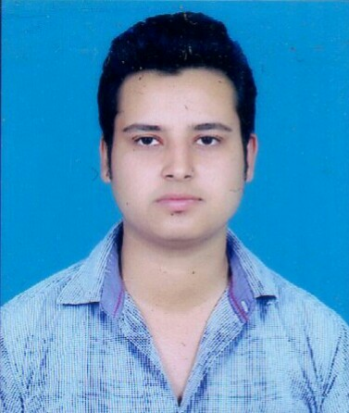

BRAJ KISHOR SHUKLA

DIPLOMA CHEMICAL ENGG.

brajkishorshukla596@gmail.com

brajshukla596@gmail.com

MO. +91 9125129208 ,9106870211

CAREER OBJECTIVE

To be a part of organization that provides an atmosphere of mutual growth and benefits, Where I can show my talent and potential.

EDUCATIONAL QUALIFICATION

* Diploma (Chemical Engg.) From Govt. Polytechnic Gorakhpur, UP in 2014 with 73.04% Marks.
* SSC from UP Board in 2011 with 80.50% Marks.

VOCATIONAL TRAINING

* Four Weeks Vocational Training From M/S. NRVS Enterprises Pvt Ltd,Jaunpur, Gorakhpur.

STRENGTHS

* Discipline, Adaptability &Team Work.

COMPUTER SKILL

* MS Office

 INDUSTRIAL EXPERIENCE

    Currently I'm working with Alkyl Amines Chemicals Ltd Dahej.It comes in Petrochemical Industry  based on PLC-SCADA,continuous process plant .Mono-Di-Tri Methyl Amines Gasious Product produced with reactant Ammonia & Methanol.

* Organization Name           :         Alkyl Amines Chemicals Ltd.Dahej-2

Designation                       :          Production Officer

Time period                       :          Feb 2018 to till date

* Organization Name          :          Bharat Rasayan Limited ;Bharuch(Gujarat)

Designation                       :           Asst. Production Supervisior

Time Period                       :           July 2017 to Feb 2018

* Organization Name          :           Ion Exchange India Ltd (At site Essar Steel Ltd Hazira)

Designation                     :           Field service Chemist(At contract basis)

Time Period                   :          Sep.2016 To July 2017

JOB DESCRIPTION

* Plant operation & manage in rotating shift.
* Supervision of SMPV(Static mobile pressure vessel) area.
* Making daily report of RM consumption.
* Maintaining all process parameter.
* Housekeeping maintaining at workplace.
* Manpower Handling.
* Safe Chemical Handling.
* Exposure of handling hazardous chemicals.
* Documentation.
* Troubleshooting.

Handling Equipments

* Continous/Batch Distillation column
* GLR & SS Reactor
* Pump Centrifugal /Reciprocating
* Heat Exchanger , ANFD & Centrifuge
* Utility: DM Plant

PERSONAL PROFILE

Father’s Name : Indra Prakash shukla

Date Of Birth : 15/03/1997

Marital Status : Single

Sex : Male

Present Address : 36 Puspkunj Society Tulsidham, Bharuch, Gujarat

Permanent Address : H NO 68P,Jungle Salikram Shivpur

Dist. Gorakhpur ,UP-273014

Hobbies : Listening Music ,Watching Comedy Movies

Lang. Known : Hindi & English

Nationality : Indian

DECLARATION

I hereby declare that the information given above is true to the best of my knowledge.

Place : Bharuch                              .    Sign

Date :  .                                                 Braj kishor shukla