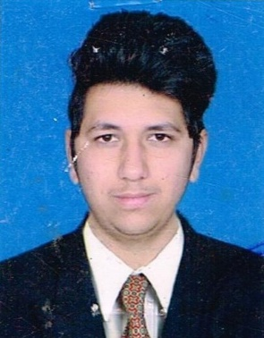Chintan D. Gajjar

8/ Shrinath Row House,

Oop. Samratnagar, Nr. Apex Honda showroom,

Isanpur, Ahmedabad-382443.

Mobile: +91-8460161586

Email ID: gajjarchintan57@gmail.com

_____________________________________________________________________________________

**Objective:**

* To work in a challenging and dynamic environment and to keep adding value to the organization that I represent and serve, while also upgrading my skills and knowledge.

**Area of interest:**

* Product Design & Manufacturing.
* Plant Maintenance.
* Electrical Designing.

**Education Qualification:**

|  |  |  |  |
| --- | --- | --- | --- |
| **Qualification** | **Board**/**University** | **Year** | **Class** |
| B.E (Electrical) | Gujarat Technological University  (Grow more institute of technology) | 2016 | 6.62 CGPA |
| Diploma (Electrical) | Gujarat Technological University  (Dalia institute diploma studies ) | 2013 | 6.05 CGPA |
| S.S.C | Gujarat secondary Education Board(GSEB) | 2010 | 51.85% |

**Job Description:**

* Preventive plant maintenance and electrical maintenance.
* Handle AMCs and proper working of ACs, Cold rooms, D.G. Set, VCB, Transformer, Motors, Earthing and salt charging.
* Checking of panels, motor – checking and greasing.
* Infrastructure development like pipelines, civil work, and other miscellaneous electric work.
* Responsible for lift working and maintenance.
* Stock taking of plant item in the stock room.
* Installation and project work of street light installation.
* Installation and project work of LT panels.
* Good knowledge of tender work & Documentation practice.
* Operation and Maintenance and Installation of water pumping station.

**Professional Experience:**

* I have working in electrical LT wiring (Industrial and commercial),

LT Panels, Street Light Installing.(Site Engineering) As an Engineer for 6 months in **Rvd Infra Solution (p) Ltd**. (Ahmedabad) (Jan 2017- May. 2017).

* I have working in Pumping Machinery & Electrical LT wiring Tender work (Project Engineer) As Electrical engineer in **Gupta Traders**, Ahmedabad

(June.2017 to May 2018).

* I have currently working in electrical and mechanical plant maintenance (Plant Engineer) As an Engineer in **Kanchan Pharma (p) Ltd**, Aslali (May 2018 to till present).

**Professional skill:**

* Good research, results oriented inters personal and communication skills.
* Initiator, keen learner, self-motivated and good analytical skills.
* Proper knowledge of various computer applications MS Office, Matlab.

**Core Competencies:**

* Problem Solving.
* Quick Learning.
* Responsible and hardworking.

# Personal Profile:

Name : Chintan D. Gajjar

Birth-date : 04th June, 1994.

Languages Known : English, Gujarat and Hindi.

Hobbies : Travelling**,** Photography.

Permanent Address : 08, Shrinath Row house, Near Muktajivan School,

Isanpur, Ahmedabad -382443.

Gujarat, India.

Contact-no : (M) 8460161586 (R) 9429907353

I hereby declare that all the entries are correct to the best of my knowledge. If chance is given to me, I assure you that, I will prove myself as an asset to your organization.

Yours faithfully,

**Chintan Gajjar.**