**CURRICULUM VITAE**

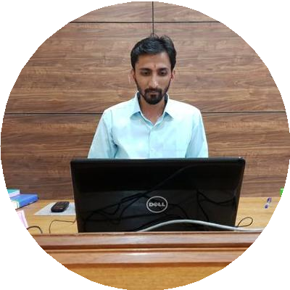

**NIKHIL MATHUR**

Phone: +91-7597000123

Email: nikhilmathur18@gmail.com

**CAREER OBJECTIVE**

* Seeking an entry-level position to begin my career in a high-level professional environment.
* Work for new skills and technologies for the betterment of society and organization
* Secure a responsible career opportunity to fully utilize my training and skills, while making a significant contribution to the success of the company.

**QUALIFICATIONS**

* Master of Business Administration in Information Technology , Pursuing Distance Learning from Jaipur National University , Jaipur
* Certification in Import Export Management from IIIEM, Ahemdabad - 2018
* Post Graduate Diploma in Computer Applications- Distance Learning from Jaipur National University , Jaipur in 2017
* Bachelor of Technology in Mechanical Engineering - 2017

**SKILLS**

* Possess a level of proficiency in both written and verbal communications
* Proficiency in Microsoft Word and Excel
* Effective time management skills
* Good Communications Skills
* Expert in team motivation.

**PROFESSIONAL EXPERIENCE**

* Service Engineer at Dunac Motors Pvt. Ltd. (Commercial Vehicle Dealer of TATA Motors), Bikaner from April 2017 to March 2019.

**Responsibilities:**

* To Carry out routine maintenance, servicing and breakdown repairs.
* Train customers in proper operation of equipments when required.
* Time to time preparing detailed Service technical reports on specific products and customer issues/complaints.
* Reporting warranty problems to Manufacturing companies using Excel Sheets.
* To conduct business with customers in professional and courteous manner.

**SUMMER INTERNSHIP**

* Completed Internship at North Western Railway Workshop , BIKANER

**HOBBIES**

Listening Music, Playing Cricket