

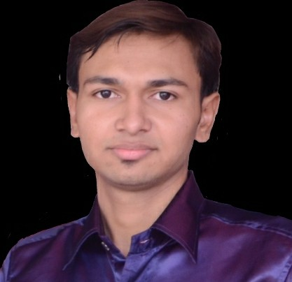
VIPULKUMAR BHARATBHAI PANCHAL
No. 77, VASANT VIHAR SOCIETY,

KATHWADA ROAD,

NEW NARODA, AHMEDABAD. 380 325

Contact No.: +91 8866820168

Email Address: panchalvipul94@gmail.com

Objective

Apply and contribute engineering knowledge to fulfill company’s objectives in their engineering development.

Profile Summary

- A fresh graduate in mechanical engineering field and completed a final year project that mechanical properties of pressure control in water pressure tank and check leackage of
solid body.
- Ability to lead and work with people well as evidenced by my active participation in campus activities.

Work Experience 2013 – 2017

GBEE ENGINEERING, KATHWADA GIDC, ODHAV.

Apr 2013 – Dec 2015

Job Level | Production/Quality Control/Trainee
Job type | Full Time
Industry | Engineering & Oil Pressure Pump, Industrial Rotary Gear Pump
Job Specialization | Engineering-Mechanical
Monthly Allowance | 1000
Job Responsibilities | Learn to design and implemented a new mixed-model assembly
 | line to accommodate a new product.
 | Help to re-organize an inventory system to prevent material
 | shortages.

PRIMA PUMPS PVT LTD
34, GVMM Au vasahat, Odhav.

Jan 2016 – Current Running

Job Level | Production/Inspection/Designing
Job type | Full Time
Industry | Submersible Pump Manufacturing (Horizontal Monoset)
Job Specialization | Engineering-Mechanical (Quality Inspection)
Monthly Allowance | 2000
Job Responsibilities | Learn to design and implemented a new mixed-model assembly
 | line to accommodate a new product.
 | Help to re-organize an inventory system to prevent material
 | shortages.

Academic Qualifications

Gujarat Technical Univercity, Ahmedabad.

Diploma in Mechanical Engineering, 2014.

CGPA: 6.22

Final Year Project

Water Pressure check leackage based project:-

The Water Pressure Pump use in solid Body to check a leackage or search Technical fault.

Extra-Curricular Activities

- 2009 to 2010 – Course Complete AutoCAD in Khodiyar Cad Center, Ahmedabad.

Skills

Skill |  | Proficiency | Years of experience
AutoCAD 2007 |  | Intermediate | 3
Microsoft Office (Word, Excel, |  | Advanced | 5
PowerPoint)
Languages (0=Poor, 5=Excellent)
Language |  | Spoken Proficiency | Written Proficiency
Gujarati |  | 5 | 5
English |  | 3 | 4
Hindi |  | 5 | 4
Other Particulars
Date of birth |  | 7th June 1994
Nationality |  | India
MyKad/Passport |  | -------
Gender |  | Male
Marital Status |  | Single
Willingness to travel/relocate |  | Will consider
Own transport |  | No
Expected Salary |  | Negotiable
Availability |  | Immediate

