

**MEET CHAUHAN**

**B.E (Mechanical Engineering)**



**E - mail** [**ID:** chauhanmeet1095@gmail.com](mailto:chauhanmeet1095@gmail.com)



**Contact No:** 8141637002, 9909953668



# Career Objective

To acquire a position in organization that provides me the opportunity to bring out my skills to help to take organization to pinnacle of success and expand my knowledge.

# Professional Profile

* Total **1 years** of experience in **chemical & pharma maintenance** plant.
* **July 18’ to December 18’** 6-month experience **in Narmada industries** in project as a supervisor.
* **3 Months** work in **ICPA Health Products Ltd.** Ankleshwar.
* Knowledge of **BMS Version 3.0 – Desigo (Siemens) & EMS rscada version pro 1.0.**
* Currently working as a apprentice trainee in Maintenance Department at **Sanofi India LTD. (Ongoing from March).**

# Academic Qualification

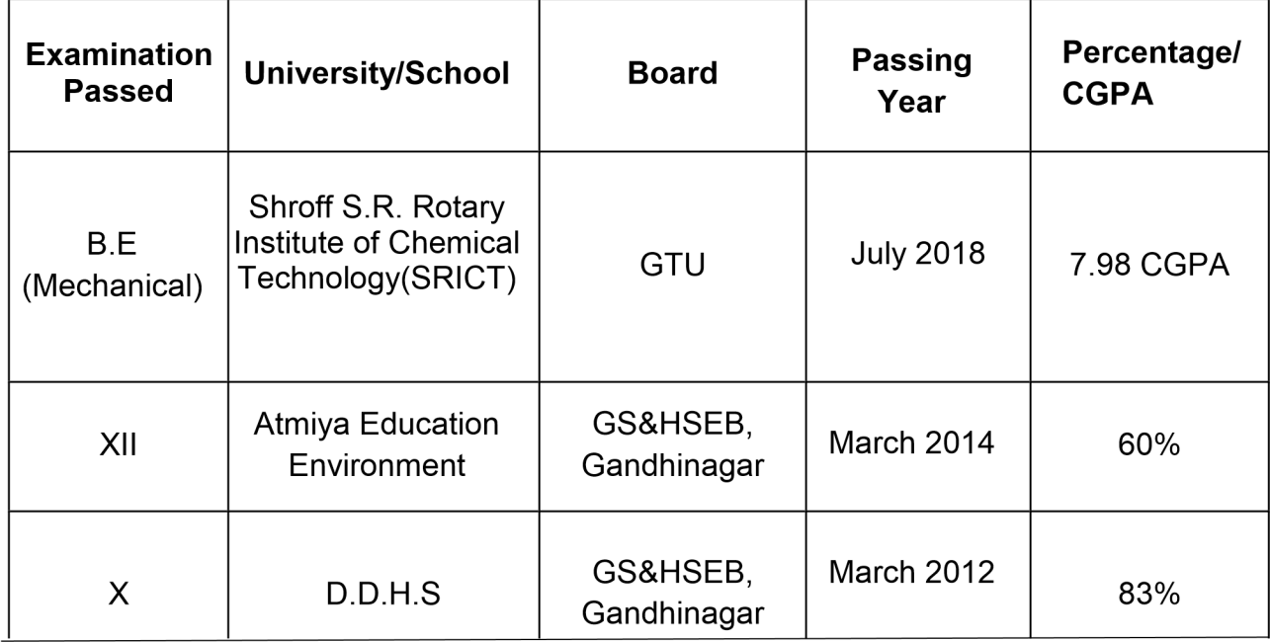

|  |  |  |  |
| --- | --- | --- | --- |
| **Experiential Learning (Summer Internship Program)** | | | |
|  | **Company Name** | UPL - 5 |  |
| **Project Title** | Maintenance |  |
| **Duration** | 30 days (1st June to 30th June 2017) |  |
| **Co-Curricular Activity** | | | |

* Executive member of sport committee in Atmiya School
* Technovation in Robo race and Aqua thrust 2017

# Personal Skills

* Ability to rapidly build relationship.
* Confidence and Determination.
* Ability to cope up with different situations.

# Personal Details

|  |  |
| --- | --- |
| **Date of Birth** | : 6th August, 1997 |
| **Gender** | : Male |
| **Residential Address** | : 629 J, Rakha Falia, Jhagadia Bharuch, Gujarat – 393110 |
| **Nationality** | : Indian |
| **Religion** | : Hindu |
| **Languages Known** | : Gujarati, Hindi and English |
| **Family Background** | : Father – Rakesh T. Chauhan ( Job - Executive Engg.) |

|  |  |
| --- | --- |
|  | Mother – Rina R. Chauhan ( Teacher) |
| **Marital Status** | : Unmarried |
| **Declaration** |  |

I hereby declare that the above information is true to the best of my knowledge.

Date: Best Regards

(Meet Chauhan)