Resume
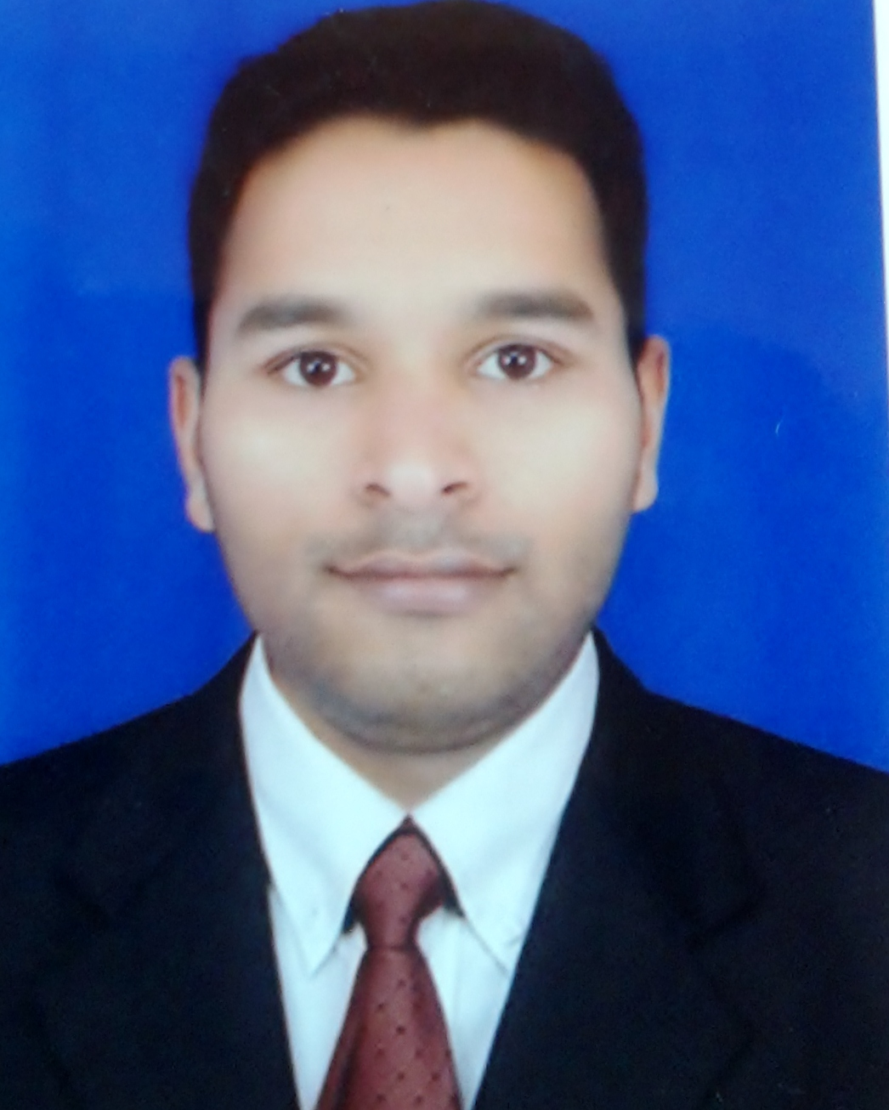
SK SAHINSHAH ALAM
E-Mail: alambdk01@gmail.com
contact: 7008874838 / 8763744899
Odisha Bhadrak.

Seeking a challenging career where I will show my inherent capabilities, enhance my skills and strengths in conjunction with the organizations goal.

OBJECTIVE

- Looking for an opportunity to prove my skill along with the development of Company and I will try my best performance along with the company.

EDUCATIONAL QUALIFICATION

Examination | Board | Year of Passing | %
10th | B.S.E ODISHA | 2008 | 66%
12th | C.H.S.E ODISHA | 2010 | 52%

TECHNICAL QUALIFICATION

Examination | University | Year of Passing | %
B.TECH (MECH) | BPUT, ODISHA | 2015 | 8.0 (CGPA)

TECHNLOGY SKILLS

- AUTOCAD 2013
- Win7 & Win8 Operating System

WORK EXPERIENCE
- 1 year working in Agarwal rubber limited as maintenance engineer at Hyderabad.
- Currently working in Maruti Suzuki Jyote Motor as Service advisor about 2.1 years Continue…

PROJECT
- 3D printer (Worked during B.TECH)

HOBBIES
- Watching and playing cricket
- Watching movie
- Listening to music.

STRENGTH
- Optimistic, punctual, disciplined and having leadership quality.
- I am be a good friends.

PERSONAL DETAILS

Name : Sk Sahinshah alam
Father's Name : Sk Inam Mohammed
Date of Birth : 19th April 1993
Nationality : Indian
Sex : Male
Marital Status : Unmarried
Language known : English, Urdu, Hindi and Odia
Address : At/Po- garadapur, Dist- Bhadrak, Odisha- 756100.

DECLARATION

I hereby declare that above-mentioned information is correct up to my knowledge and I bear the responsibility for the correctness of the above-mentioned particulars.

Date: (Sk Sahinshah Alam)
Place: Signature

