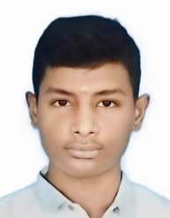**NAME:** K.S.PRAGATHESH

**EMAIL ID:** pragathesh715@gmail.com

**MOBILE NUMBER:** 7708809277

**ADDRESS:** 230/110 KVSS E.B Quarters,

P.C.Patty(Po),Theni(Tk).

**CAREER OBJECTIVE:**

* Obtain a responsible position in an organization with the best capabilities,skills and knowledge.

**ACADEMIC QUALIFICATION:**

* 10th From Bagya Matriculation School In Allinagaram.
* ITI from Government Industrial Training Institute in Theni.

**PROFFESSIONAL SKILLS:**

* Basic knowledge of computer.
* Typing.

**WORK EXPERIENCE:**

* Fresher.

**PERSONAL DETAILS:**

**NAME:** K.S.PRAGATHESH,

**DATE OF BIRTH:** 03/07/2006

**FATHER NAME:** S.KANAGARAJA,

**GENDER:** MALE,

**NATIONALITY:** INDIAN,

**MARITAL STATUS:** UNMARRIED,

**LANGUAGES KNOWN:** TAMIL,ENGLISH,

**HOBBIES:** DRAWING.

**DATE:**

**PLACE: TRAINES SIGNATURE**