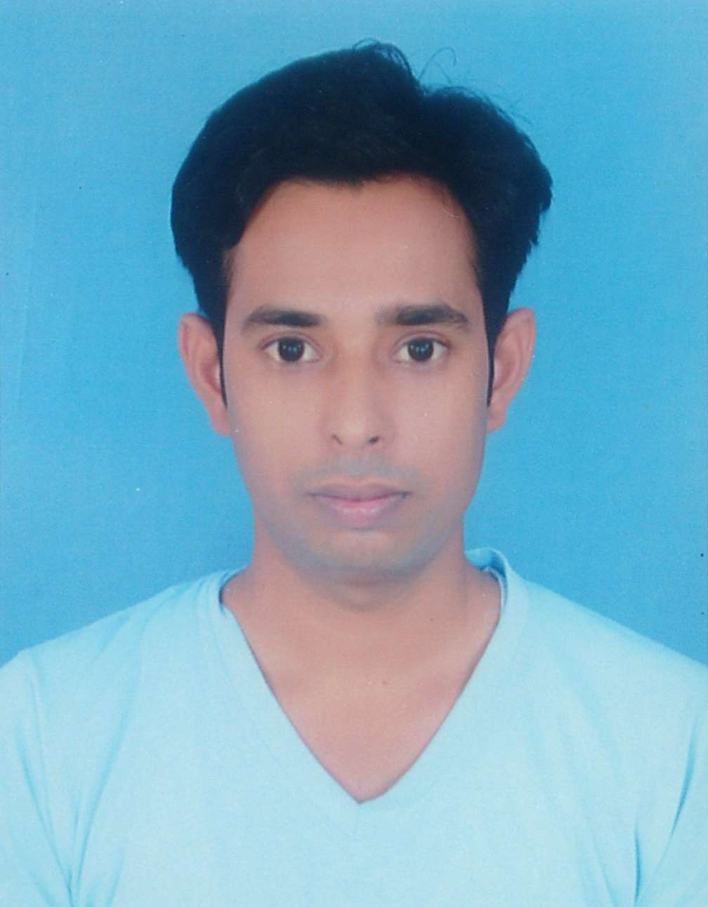

**Jayprakash Katariya**Diploma **Mechanical** Engineering

Contact No. :-7226912984

E-mail :- katariya.jay543@gmail.com

**CAREER OBJECTIVES**

To work in a firm with a professional work driven environment where I can utilize and apply my knowledge, skills which would enable me as a Fresh Diploma Engineer to grow while fulfilling organizational goals.

**BASIC ACADEMIC CREDENTIALS**

|  |  |  |  |
| --- | --- | --- | --- |
| **Qualification** | **Board/University** | **Year** | **Percentage** |
| Diploma  Mechanical  Engineering | Sir Bhavsihji Polytechnic Institute (G.T.U), BHAVNAGAR | 2015  **Project**  **( Electric Robotic Arm)** | 7.69 CPI  7.89 CGPA  DISTINCTION |
| I.T.I.  Machinist Grinder | I.T.I. Tarshali,   BARODA | August 2008 to July 2010 | 78 % |
| C.N.C.  Programming | Parantap Institute,  BARODA | April 2011 | Second Class |
| H.S.C  (Arts) | G.H.S.E.B | March 2008 | 64.57 % |
| S.S.C | G.S.E.B | March 2006 | 59.57 % |

**EXPERIENTIAL LEARNING ( INTERNSHIP PROGRAM)**

|  |  |  |  |
| --- | --- | --- | --- |
| **Training** **Name** | **Institute/Company** | **Duration** | **Percentage** |
| Apprentice Training | F.A.G. Bearing India Ltd.  Maneja, BARODA | Oct 2010   to   Oct 2011 | 80.0 % |
| C.N.C   Turning & Milling   Training | Indo German Tool Room  Indore,( M.P) | March 2012  to   March 2013 | *-* |

**WORK EXPERIENCE**

**(1) Company Name :-** F.A.G Bearing India Ltd Maneja, BARODA

**Designation :-** Diploma Trainee (Randstad contract)

**Duration :-** 15th July 2015 to 15th July 2016 ( One year contract )

**Role :-** Lathe & Surface grinding Machine Operator. ( Tool room)

**(2)**  **Company Name :-** Rivulis irrigation india private ltd

**Duration :-** 27th july 2017 to 27th feb 2018

**Role :-** Technical Associate

**Department :-** production  
 **Current CTC :-** 136000Rs. per Annual.

**TRAINING REPORT**

* **Report on various production department, programming and in Quality control aspects.**

**COMPUTER PROFICIENCY**

* **Auto cad 2016 , Creo 2.0 pro e design**

**REFERENCES**

* **Available on Demand.**

**PERSONAL DETAILS**

* **Father’s Name :- Jashbhai Katariya**
* **Permanent Address :- 23, katariya Nivas,To: patod, Ta: Padra, Di: Baroda -391440**
* **Date of Birth :-** 20th December , 1990
* **Language Known :-** English, Hindi, Gujarati
* **Marital Status :-** Single
* **Nationality/Religion :-** Indian / Hindu
* **Interest & Hobbies :-** Playing Cricket, Painting.

**DECLARATION**

I do hereby declare that the above information is true to the best of my knowledge**.**

**Place: Katariya Jayparakash .J**

**Date: (Signature)**