# CCURRICULM VITAE

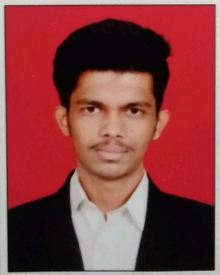

**JORA ALPESH RAMSHIBHAI**

## At Post-Khera, near bus stand

## Ta.Maliya hatina, Dist.Junagadh

362250

Gujarat

**Mobile**:+917874336852

## **Email**: [joraalpesh@gmail.com](mailto:joraalpesh41@gmail.com)

**Career Objective**

* To obtain a position that will allow me to utilize my technical skills and willingness to learn in making an organization successful.

|  |  |  |  |
| --- | --- | --- | --- |
| **Course Details** | | | |
| **Degree:** | B.E | **Specialization:** Chemical Engineering |  |

|  |  |  |  |  |
| --- | --- | --- | --- | --- |
| **Education** | | | | |
| **Qualification** | **Institute** | **University/Board** | **Year of Passing** | **CGPA or**  **%** |
| B.E | Government Engineering College, Valsad. | Gujarat Technological University, Ahmadabad | 2019 | 6.45 |
| 12th | Rashtriya Shayar Shree Zaverchand Meghani Smark Higher Secondery School Bagasara | (GSHEB Board) | 2015 | 64.61 |
| 10th | Mans Vidhayalay, Junagadh | (GSEB Board) | 2013 | 72.8333 |

Personal Details

* Father’s Name : Mr.Ramshibhai Mashribhai Jora
* D.O.B : 16 Octember 1997
* Gender : Male
* Nationality : Indian
* Language Known : English, Hindi, Gujarati.
* Maritial Status : Unmarried
* Hobbies : Listening music,Travelling,

**Project taken**

* Me and my Teammate’s working on Extration of Essention Oil

**Field of interest**

* Production Department
* Product Quality Management
* Process engineering

**Computer Proficiency**

**Declaration**

* I hereby declare that all the particulars given above are true to the best of my knowledge and belief.

### Date :

* Word
* Excel
* Power Point

**Signature**