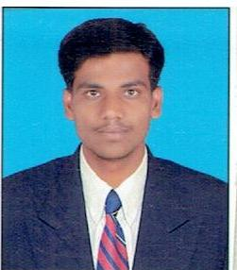
Amol Balu Ghadge
aghadge989@gmail.com
7447255543
Career objective

Owning responsibility toward my duty enhance my knowledge and use my skill towards the Growth the company and self improvement.
Academy Qualifications

EXAM | INSTITUTE | UNIVERSITY | YEAR | PERCENTAGE
BE(mechanical) | PREC,loni | SPPU | 2019 | 72.16
TE | PREC,loni | SPPU | 2018 | 70.83
SE | PREC,loni | SPPU | 2017 | 57.96
DME | K.S.S.E.D.POLY RAKSHI | MSBTE | 2016 | 67.18
SSC | R.S.Shevgaon | PUNE | 2011 | 68.18
Curriculum Activities
- Attended 16 Days of Soft Skill Seed InfoTech.
- Attended workshop of. Modern vehicles.
- Attended CNC course
- Obtain third position amongst the student appearing from p.Dr.v.v.p.poly..loni at MSBTE examination.
Personal Skills
- Ability to Solving problems
- Team Work
- Making friends Quickly

Technical Skills
- Catia
- Ansys
- Master cam

Hobbies
- Listening music
- Surfing Internet
- Traveling

Project
- Multipapose three in one griculture Machine
- Compressed air operated vehicle
- Role- Design And Development

Personal Details
- Permanent Address A-Najik Babhulgaon , Post. Rakshi,Tal-Shevgaon,
- Dist - Ahemadnager
- State Maharashtra
- Date of Birth. 20/July/1995
- Gender Male
- Marital Status Unmarried
- Language known. English, Hindi, Marathi

Date: Amol Balu Ghadge

Place :

