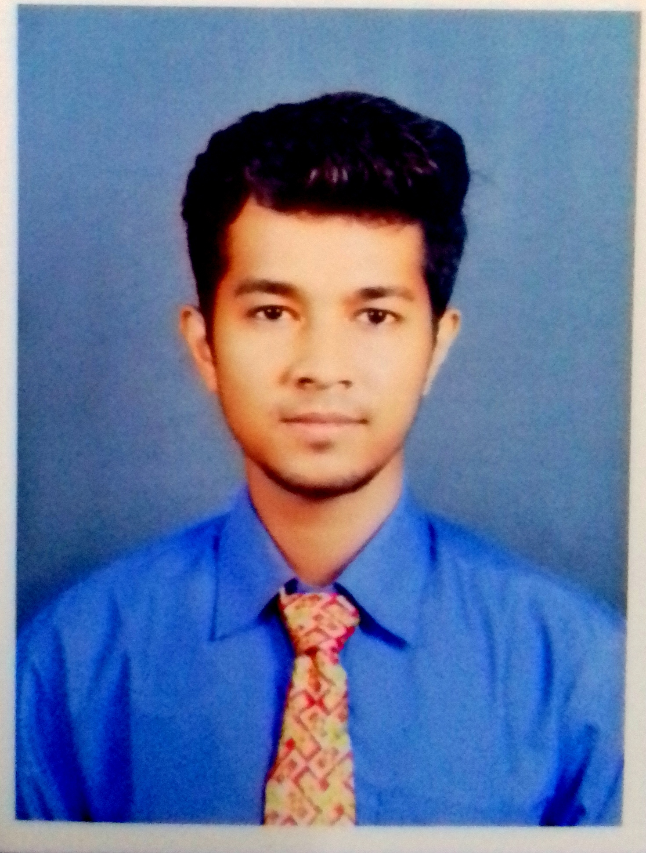**CURRICULUM VITAE**

**Name:** Ranadeep Karmakar

**Phone no**: 9851465905

**E-mail Id :** ranadeepelectrical@gmail.com

**Career Objectives:**

* Contribute my technical and learning skills in a position with a growing and dynamic firm.
* To pursue a career with an organization having a global vision, which in courage creativity and offers an opportunity to learned and develop both in professional and personal life, with to use and enhance my knowledge and ability to work in a group.

**Academic Qualification:**

|  |  |  |  |  |
| --- | --- | --- | --- | --- |
| **Exam Passed/ Appeared** | **Board/ University** | **School/**  **College** | **Year Of Passing** | **Marks** |
| B-tech in electrical engineering | Moulana AbulKalam Azad University of technology,West Bengal | Techno India College of Technology | 2018 | Cgpa - 6.87 point |
| Diploma in electrical engineering | West Bengal State Council Of Technical Education | The New Horizons Institute of Technology | 2014 | 68.6 % |
| Higher Secondary (12th) | West Bengal council of higher secondary education | Belrui N.G Institution | 2011 | 55.80 % |
| Secondary(10th) | West Bengal Board of Secondary Education | Belrui N.G Institution | 2009 | 62 % |

**Technical Competency/ Skills Known :**

* Primary maintenance of testing instruments / equipments as per S.O.P. for maintenance
* Preparation of test set ups for submersible pumpset testing
* Testing of submersible pumpsets as per IS 8034 – 2002 in NABL lab.
* Training on renewable PV solar panels with solar panel installation under central govt. (NISE)
* International Institute for Advance Training on Control & Automation ( Industrial Electrical)
* Soft skills.
* Four wheeler driving licence

**Job Experience:**

* Working as a **Assistant engineer** at **consumer education and research centre (**energy cell**)** from sept. 2018 till now.

**Also associated with Torrent power Ltd. Doing Energy meter testing & Problem solving in**

**Distribution Side (Consumer End).**

**Training:**

* Durgapur Projects Limited (**Power plant**)
* Training on renewable PV solar panels with solar panel installation under **central govt.** (NISE)
* Laboratory Technicians/Technical Assistants for energy efficiency, star labelling and other electrical testing for environmental criteria under **central govt (GSDP)**
* International Institute for Advance Training on Control & Automation ( **Industrial Electrical)**
* Soft skills

**Seminars & Workshops:**

* Robotics IIT Bombay
* Ardent-Home Automation

**Projects:**

* Arduino smart Robot
* Single Phase Inverter
* Laser voice transmission system
* GSM based smoke fire monitoring system

**Extra Curricular Activities:**

* Martial-art.
* Making technical projects.
* Danceing
* Singing.
* Travelling

**Personal Details:**

S/o: Ranjit Karmakar

Place: BishnuBihar Colony,Sitarampur

Dist: Burdwan

Pin: 713359

Date of birth: 14/1/1993

Gender: Male

Marital: Single

Nationality: Indian

Language know: Bengali, English, Hindi

**Declaration:**

I hereby declare that all the information given above is correct is the best of my knowledge.

___________________

(Ranadeep Karmakar)