Curriculum Vitae

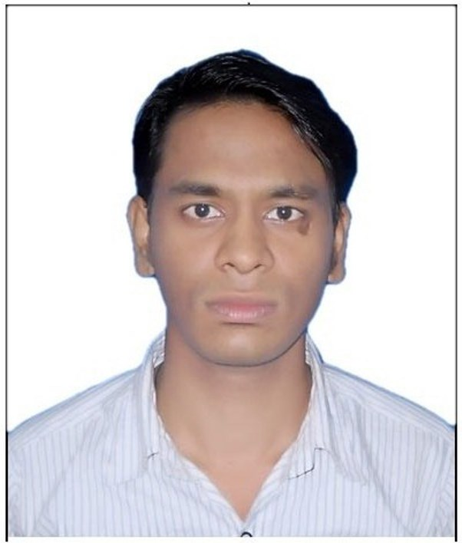

# ABHISHEK KUMAR

HANUMAN CHOWK BIRGHANI(CHAMPA),

WARD NUMBER-1,

DIST-JANJGIR-CHAMPA, (C.G.),495671

E-MAIL  : [abhiabv7@gmail.com](mailto:abhiabv7@gmail.com)

CELL NO : +919893330197, +919098681432,

|  |
| --- |
| OBJECTIVE: |
| A Mechanical fresher seeking challenging opportunity to work for organization to enhance my knowledge, skills and techniques which can benefit the organization. | |

|  |
| --- |
| EDUCATIONAL QUALIFICATION: |
| Graduation  in  B.E. : | SCHOOL/COLLEGE | UNIVERSITY | BRANCH | % |
| Bharti College of Engineering And  Technology Drug,  Year-2016 | Chhattisgarh Swami Vivekananda Technical University, Bhilai | Mechanical | 63.9 |
| 12 th : | Gyandeep hir.sec.  School janjgir  Year -2010 | CGBSE, Raipur | Maths | 50.9 |
| 10 th : | Rashtriya sewa  Yojana hir. Sec.  School basantpur (janjgir)  Year -2007 | CGBSE, Raipur | All Subject | 54.6 |

|  |
| --- |
| STRENGTH: |
|  | * Positive Attitude * Ability to work in a team. * Good listening skills * Punctuality |

|  |
| --- |
| WORK EXPERIENCE : |
| Organization: | | Designation: | Tenure: |
| K. L. Energy Pvt Lim Chaal; | | Supervisor | 9 Month |
| Same Time Pvt Lim Bilaspur; | | Computer Operator | 8 Month |
| Aardhya consultancy Pvt Lim Bilaspur; | | Team leader | 6 Month |

|  |
| --- |
| Training: |
|  | Undergoing skill development training at GROW CENTRE with  DR. REDDY’S foundation Bilaspur(C.G.)   * Communication skill * Soft skill * Aptitude * English typing * Personality development * Digital Computer literacy   cnc |

|  |
| --- |
| COMPUTER PROFICIENCY: |
| Tools: | MS-Word, MS-Power Point, MS-Excel etc. |
| Technical Software : | AUTOCAD-2012, PRO-E ,ANSYS-14.0 |

|  |
| --- |
| VOCATIONAL  TRAINING : |
| Company Name: | Simplex casting limited,  Bhilai | Bhilai steel  Plant,  Bhilai | Chhattisgarh state  Electricity board,  korba |
| Duration: | 30 Days | 12 Days | 27 Days |
| Role: | Trainee | Trainee | Trainee |

|  |
| --- |
| ACADEMIC PROJECTS UNDERTAKEN : |
|  | Automatic Breaking System. |

|  |
| --- |
| PERSONAL INFORMATION: |
| Branch: | Mechanical Engineering |
| Father: | Let Mr. Shiv Ram sahu |
| Mother : | Dulishvari sahu |
| Date Of Birth: | 26/05/1991 |
| Gender: | Male |
| Languages: | English, Hindi. |
| Interest: | Playing Chess, Traveling etc. |
| Nationality: | Indian |

Declaration:

I do hereby declare that the above information is true to the best of my knowledge**.**

**Place:**

# Date: (Abhishek Kumar)