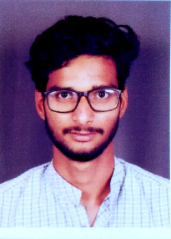

Name : Mr. Rajesh Karunakar Yerguntala
Mobile : +91 9503480459
Email : rajesh113100@gmail.com
Branch : Automobile Engineering

Career Objective
Pursuing a position in the automotive industry in which I can utilize and build upon my current knowledge of modern automotive manufacturing and engineering.

Qualification Details

Sr. No. | Exam | Board/University | Year | Result
1 | B.E. Automobile Engineering | Shivaji University | 2019 | 64.75
2 | Diploma in Automobile Engineering | MSBTE | 2016 | 70.97%
3 | S.S.C | Pune | 2013 | 76.40%

Project Details
- B.E Project -: Development of multipurpose hand tractor for cultivating a varieties of crops in small scale farm
- Diploma Project -: Automatic Railway Platform by using power window scissor mechanism.

Technical Skills
- ANSYS
- CATIA
- CAD-CAM
- Management skill

Training .
- Ashta Liners Pvt.Ltd, Ashta 1st June 2018 to 16th June 2018.
- Completed training programme on Entrepreneurship Development.

Other Activities
- 3rd Winner of Pahel start up idea project competition.
- 2nd prize in diploma project competition.
- Participated in MSBTE project exhibition.
- Head of Innovation college technical event.
- NPTL course of Product Design & manufacturing

Personal Information

D.O.B : 10-08-97
Marital Status : Single.
Gender : Male
Languages Known : English, Telugu, Hindi, Marathi, Kannada

Declaration

I hereby declare that above given details are correct in the best of my Knowledge.

Rajesh Karunakar Yerguntala

