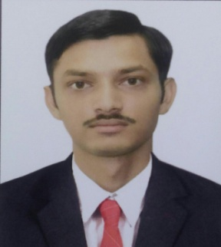**PANCHAL BHARATKUMAR MANOJBHAI**

At &Po - Saring , Bazaar Faliya

Ta – Karjan, Dist -Vadodara

Mo. - 7046835033

Email - <bharatpanchal009@gmail.com>

Seeking of entry level position with a growth oriented organization in area of

* Engineering in Mechanical Branch

**PROFESSIONAL PROFILE**

* Building an Engineering professional with a **Bachelor Degree** in **MECHANICAL ENGINEERING** From “Shri Sad Vidya Mandal Institute Of Technology’’,Bharuch under Gujarat Technology University, Gujarat.
* Complete vocational training at GFL , DAHEJ GIDC (duration 3 week) as Mechanical trainee.

**EDUCATION**

|  |  |  |  |  |
| --- | --- | --- | --- | --- |
| Degree | Institute | Board/university | CGPA / % | Year |
| B.E. | Shri Sad Vidya Mandal Institute Of Technology ,Bharuch | GTU | CGPA- 7.49  CPI- 7.62 | 2017 |
| HSC | Diwan Dhanjishaw High School , Jhagadia | GSHSEB | 67.50 % | 2013 |
| SSC | Diwan Dhanjishaw High School , Jhagadia | GSEB | 75.80 % | 2011 |

**INTERNSHIP**

**Undergone in training program At “GFL, DAHEJ GIDC’’ in POWER PLANT and Central Workshop as a part of Engineering curriculum (Duration: 3 week)**

**PROJECT DETAIL**

I had done academic project on **“Comparative Stress Analysis and Optimum Selection of Reinforcement Pad’’**

* The main objective of this project is to decrease overall fabrication cost by redesign of Reinforcement Pad
* The other objective is to save material and reduce stress concentration.

**PERSONAL DETAIL**

Date of Birth : 9th July, 1996

Language known : Gujarati, English, Hindi

Hobbies : Reading Novels, Playing Chess. Volleyball

Collecting Information about Defence Equipment

Your faithful

Bharat Panchal