***Curriculum vitae***

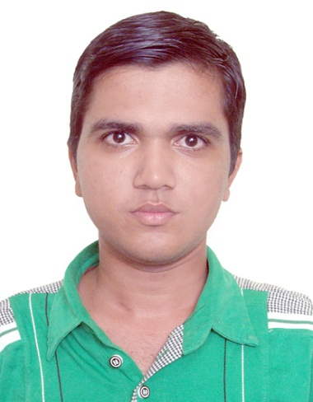VISHAL N. PRAJAPATI

18, Sabartat society,

Nr. Keshavbag Vadi,

Nawa Vadaj,

Ahmedabad-380013

Gujarat.

**Contact No: 9722123423**

**Email :** [**vishalmech92@yahoo.com**](mailto:vishalmech92@yahoo.com)

**Objective:**

To work with the progressive organisation, where I contribute my technical skills and knowledge to achieve the organizational objectives.

**Industrial Training:**

**“Techno Industries Limited”**, Vatva, Ahmedabad for the duration of 15 days.

**Academic Calendar:**

Graduation Level **:** Bachelor of Engineering

Branch **:** Mechanical Engineering

Name of the Institute **:** Lukhdhirji Engineering College, Morbi

University **:** Gujarat Technological University

|  |  |  |  |  |  |
| --- | --- | --- | --- | --- | --- |
| **Degrees** | **School/**  **College** | **Board/**  **University** | **Percentage** | **Year** | **Grade** |
| B.E. In  Mechanical Engineering | Lukhdhirji Engineering College, Morbi | G.T.U. | 6.71/10 | 2014 | First |
| HSC | C.U.Shah higher Secondary School, Ahmedabad | GSHEB | 68.20 | 2009 | First |
| SSC | Prerana higher secondary school, Ahmedabad | GSEB | 77.38 | 2007 | Dist. |

**Project Work:**

**Title:** Design and Development of Bowl Vibratory Feeding System for Screw raw material with specific orientation.

**Duration:** During 7th and 8th semester in Mechanical Engineering.

**Profile Details:**

|  |  |  |
| --- | --- | --- |
| **Name:** | : | Vishal N. Prajapati |
| **Fathers Name** | : | Nareshbhai M. Prajapati |
| **Date of Birth** | : | **21-08-1992** |
| **Marital Status** | : | **Unmarried** |
| **Languages known** | : | **English, Gujarati** |
| **Nationality** | : | **Indian** |
| **Hobby** | : | **Listening music, Chess, Riding** |

**Work experience:**

**Lallubhai Amichand Limited, Vatva at post of Q.C. & Production Engineer at Non-stick department, Since November-2013 to Octomber-2014.**

**Mehta Nanavati & Co., Gota at post of Quality Engineer of Valve Industries, Since November-2014.**

**Company Profile: Lallubhai Amichand limited** We introduce ourselves as manufacturers and exporters of a wide range of cookware since 1911. A basket of our brands includes queen, cycle, and elite. We are a well-respected household brand in Indian market. Our cookware range covers items made from aluminum and stainless steel, and with or without nonstick/anodized coating.

**Mehta Nanavati & co.**

 We introduce ourselves as manufacturers and exporters of a wide range of valve since 1962. We are a well-respected household brand in Indian market. Our valve range covers items made from casting and IC. We made of many types of valve like gate valve, ball valve & check valve.

**Ability:**

|  |
| --- |
| * Self-motivated with strong planning, organizational and leadership skills. * Good communication & soft skill. * Always Eager to learn new things from surrounding. * Hardworking, Honest, Goal Oriented, Adjustable in any working environment. * Become a good team player. * AutoCAD. * Lathe machine, drill machine.   Current CTC : Rs. 2,16,000/- Per annual  Expected CTC : Rs. 2,40,000/- Per annual  Notice period : 15 Days. |

**Declaration:**

* I declare that the above information furnished by me is true to the best of my knowledge.

**Date: - Vishal N. Prajapati**