**STEBIN BENNY**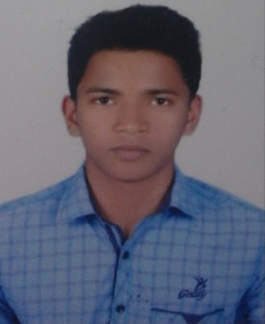

PRAKUZHYIL HOUSE

BANDADKA P.O

CHENGALA VIA

KASARAGOD, KERALA

PIN:671541

bbstebin@gmail.com

PH: 8138046180

_____________________________________________________________________________________

**CAREER OBJECTIVE:-**

To obtain a position of responsibility, that utilize my skills and experience and keep to work in an environment where I can enrich my knowledge. To associate with an organization which recognize my skill set and gives me a chance to update my knowledge and be a part of the team that excel in work towards the growth of the organization.

**EDUCATIONAL QUALIFICATION:-**

|  |  |  |  |  |
| --- | --- | --- | --- | --- |
| **EXAM PASS** | **NAME OF INSTITUTION** | **BOARD/UNIVERSITY** | **YEAR** | **PERCENTAGE OF MARKES** |
| Mechanical  engineering | North MalabarInstitute ofTechonology,Kanhangad, | APJ Abdul Kalam Technological University,Thiruvanatapuram,Kerala | 2015-2019 | 62% |
| 12TH | Government Vocational Higher Secondary School Iriyanni, kasargod | Government of kerala | 2013-  2015 | 75% |
| 10TH | Tagore Public School,Rajapuram,Kasargod | CBSE | 2012-  2013 | 94% |

**TECHNICAL SKILLS:-**

Basic Computer Knowledge,MS word, Workshop, MS Excel, CAD, C, C++.

**ACHIEVEMENTS:-**

* Participated in national service camps
* Participated in National Level Multi-Fest “ADVAYA7” Organisedby Government Engineering College Idukki.
* Volunteered in CYGNUS18-National level multi fest of NMIT
* Participated in lions club camp.

**HOBBIES:-**

* Cooking different cuisines
* Listening music
* Spending time with family
* Travelling
* Cycling

**INTERPERSONAL SKILLS:-**

* Ability to work under pressure and team player.
* Creative thinking with great diversity to adjust in any type of work environment
* Caring attitude ,good communication.
* Positive outlook and open minded approach
* Punctual
* Self-confident , hardworking .
* Like to learn new things.

**PERSONAL DETAILS:-**

Name : STEBIN BENNY

DOB : 25-02-1998

Age : 21

Gender : Male

Place : Kasaragod

Nationality : Indian

Father’s Name : BENNY JOSEPH

Mothers Name :LYSA

**LANGUAGE:-**

To Read : English, Hindi, and Malayalam.

To Speak : English, Malayalam, Tamil.

To Write: English, Hindi and Malayalam.

**DECLARATION:-**

I hereby declare that the above written particulars are true to the best of my knowledge

Place: Kasaragod STEBIN BENNY

Date: