Products of the Company

Our company V.K. Pack Well Pvt.Ltd. has manufactured the most technology driven and user-friendly product for the farmers Advance Sprinkler Irrigation System through Rain pipe “RAIN IRRIGATION SYSTEM”with the focus on the most natural, precious and finite resource i.e., “WATER” that must be used carefully and to be preserved for future sustainability. It will also help to “TRIPLE” the income of our Indian farmers and improve their livelihood.

In the same context, the product which is manufactured by our company is of high level of quality for our end –users “FARMERS”. We deliver and make the most reliable and good quality product for our customers.

The company has a patent on "LAMINATED POLYETHYLENE WOVEN FABRIC PIPES" in two countries (India – 311316& China - ZL201280061688.3).

The most honoured and the awarded products of our company are listed below:
- Advance Sprinkler Irrigation System through Rain Pipe; This is one of the revolutionary product in our range. This product Increase productivity with water, time and labour saving.

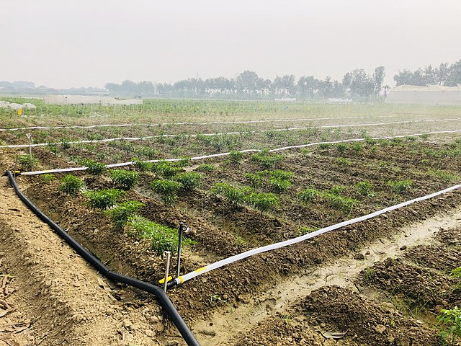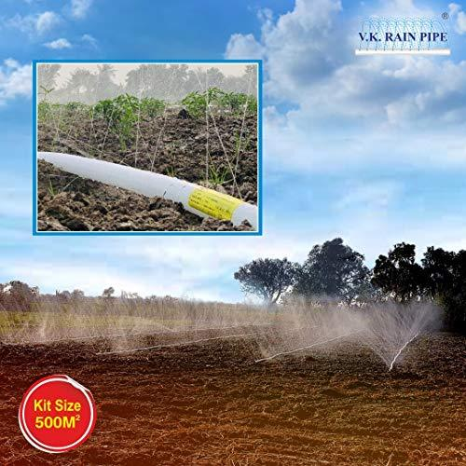

- HDPE Laminated Woven Lay Flat Tube for Use in Main and Sub-main of Drip Irrigation (IS 16627: 2017) CML No. 9300063307, this product of our company was first certified under BIS license in India.

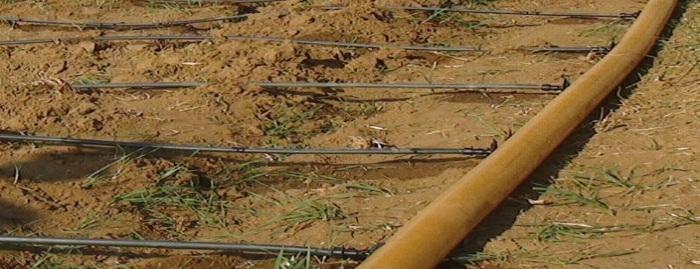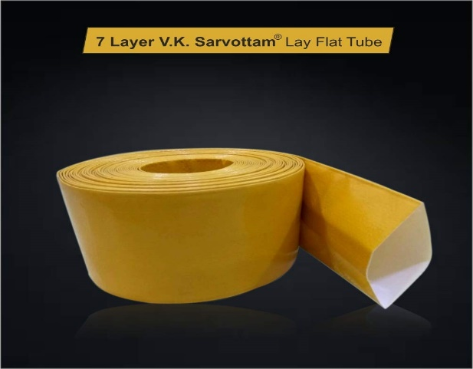

- HDPE Laminated Woven Lay Flat Tube for Irrigation (IS 16190 : 2014) CML No. 9300002299, is the first license issued by BIS to our company.

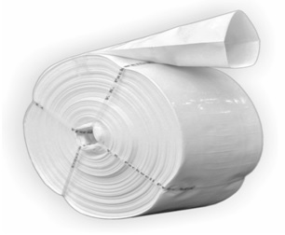

- HDPE Tarpaulins (IS 7903 : 2017) CML No. 9922903, was obtained first license which is issued by BIS for this product in north India.
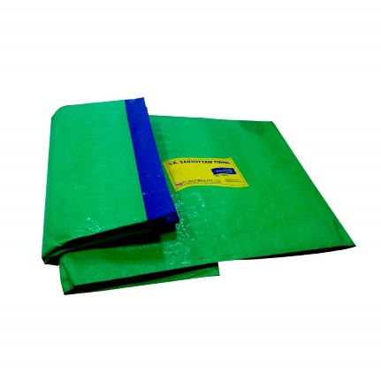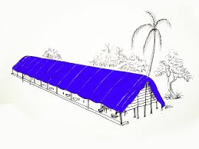

- HDPE Geomembrane for Waterproof Lining (IS 15351: 2015) CML No. 2647565, this is also the first license obtained in Northern India.

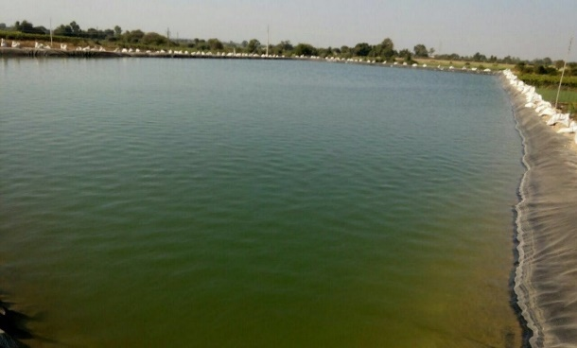
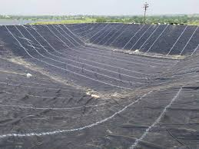

- HDPE Woven Beds for Vermiculture(IS 15907 : 2010) CML No. 4859691, this product is also in subsidy schemes of some States and having rate contract with Madhya Pradesh, Chhattisgarh and Uttarakhand Agriculture Department.

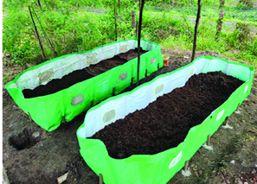

- Sprinkler Irrigation system compatible with HDPE Laminated Woven Lay Flat tube

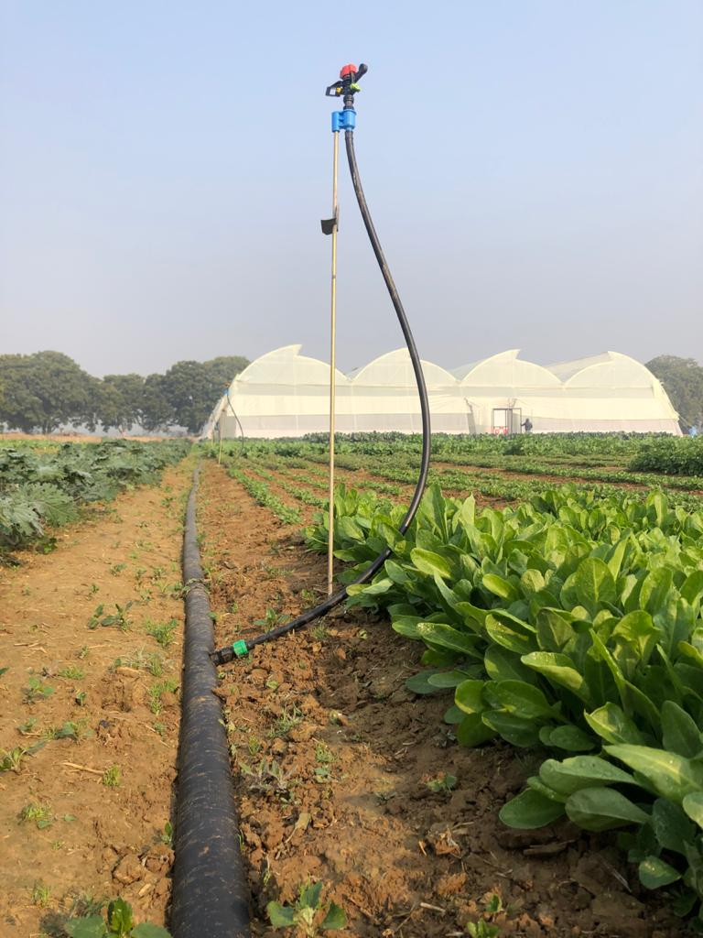

- Terrace Garden Grow Bag with HDPE laminated woven fabric

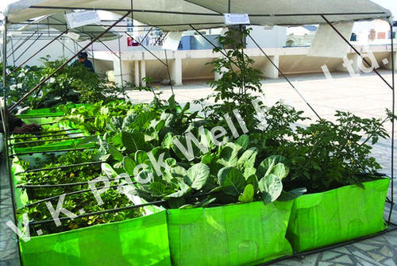

- AJOLA BED with HDPE laminated woven fabric
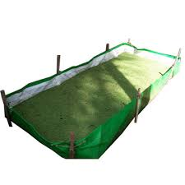

We have 6 manufacturing unitswhich have a total working space of 14,000 square meters. We daily process and manufacture various range of products like
- From 1,00,000 metre to 2,25,000 metre running per day Woven Lay Flat Tubes.
- From 10,000 - 50,000 sq. metre per day Geo-Membranes,
- 1,00,000 sq. metre and above per day tarpaulin and;

Also, we manufacture Rain Irrigation System for 50 Hectare areas for our customers.

The company Vision is “to make the best product on the basis of quality, reliability, efficiency, and cost-effectiveness. To carry out checks and controls on every stage of production so as to prevent any spurious products or costly delays.”

The company’s ‘state-of-the-art manufacturing facilities are based in the heart of the city at Kanpur, Uttar Pradesh which was also known as “Manchester of East India”. It is engaged in supply of quality Agricultural as well as non-agricultural products under the brand name of “SARVOTTAM”.

Our quality-oriented business policies and in-house laboratories make us able to bring forth a wide gamut of matchless products. In our company we have trained and qualified manpower strength across company at various levels i.e. senior, middle and junior levels.

We have 3 Sales Offices based at Kanpur, Uttar Pradesh and 1 Regional Office at Vadodara, Gujarat.Our annual turnover is more than 130 crores per annum, which is a remarkable achievement. The company also focus at various BTL, ATL marketing activities in multiple aspects. We have Pan India presence approximately 900+ Dealers network for its all range of products. We have lots of comprehensive benefits of lightweight construction, waterproof properties, heat-welded strength, rust, and chemical resistance, UV treated weather sustainability and competitive price of our offerings. We are also into e-commerce; our varieties of products are listed on Amazon and Flipkart online and we deliver the products at Pan India which includes more than 40 percent pin codes and covering all the states of India, which the company has not left any stone unturned to serve its consumers at Pan India.

We also have in-house state-of- the- art quality checking laboratories for quality control and quality assurance. Our Several products are manufactured according to the BIS (Bureau of Indian standards) norms and our labs are well-equipped with the advanced technology equipment to test our quality products. All products are tested under strict norms mandates of BIS specifications.

We are a professionally managed an ISO 9001, ISO 14001 & OHSAS certificates with the manufacturing capacity of approx.10000 MTA from our 6 units.

Our Objective is to deliver Quality products with minimum cost to our valued customer – “FARMERS”.

Company profile video: https://www.youtube.com/watch?v=27DcFpV-Q_I
Company website: www.vkgroupindia.in
Company CIN: U21098UP2007PTC032936
Email ID: md@vkgroupindia.in, psmd7@vkgroupindia.in
Facebook page: https://www.facebook.com/VKPACKWELLINDIA/

